JavaFX application

Name -Aaviraj Nikumbh PRN-24070126123 AiMl B2
Assignment 10 : JavaFX application to perform CRUD operations on database through UI
Github:- https://github.com/AaviRaj1702/Java_Files

#MainApp.java
import javafx.application.Application; import javafx.geometry.Insets; import javafx.geometry.Pos;
import javafx.scene.Scene; import javafx.scene.control.Alert;
import javafx.scene.control.Alert.AlertType; import javafx.scene.control.Button;
import javafx.scene.control.Label; import javafx.scene.layout.BorderPane; import javafx.scene.layout.VBox; import javafx.stage.Stage;

import java.sql.Connection;

public class MainApp extends Application {

static Connection con;

@Override
public void start(Stage primaryStage) {

try {
con = RestaurantJDBC.getConnection();

RestaurantJDBC.createTables(con);
} catch (Exception e) {

Alert alert = new Alert(AlertType.ERROR); alert.setTitle("Database Error"); alert.setHeaderText("Could not connect to database."); alert.setContentText(e.getMessage()); alert.showAndWait();
return;
}

showMainMenu(primaryStage);
}

public static void showMainMenu(Stage stage) {

Label titleLabel = new Label("Restaurant Management System"); titleLabel.setStyle("-fx-font-size: 20px; -fx-font-weight: bold;");

Label subLabel = new Label("Select a table to manage:"); subLabel.setStyle("-fx-font-size: 14px;");

Button restaurantBtn = new Button("Manage Restaurants"); Button menuItemBtn = new Button("Manage Menu Items"); Button exitBtn = new Button("Exit");

restaurantBtn.setPrefWidth(220); menuItemBtn.setPrefWidth(220); exitBtn.setPrefWidth(220);

restaurantBtn.setOnAction(e -> {
RestaurantUI restaurantScreen = new RestaurantUI(stage); restaurantScreen.show();
});

menuItemBtn.setOnAction(e -> {
MenuItemUI menuScreen = new MenuItemUI(stage); menuScreen.show();
});

exitBtn.setOnAction(e -> { try {
if (con != null && !con.isClosed()) con.close();
} catch (Exception ex) { } stage.close();
});

VBox vbox = new VBox(15); vbox.setAlignment(Pos.CENTER); vbox.setPadding(new Insets(40));
vbox.getChildren().addAll(titleLabel, subLabel, restaurantBtn, menuItemBtn, exitBtn);
BorderPane root = new BorderPane(); root.setCenter(vbox);
Scene scene = new Scene(root, 450, 350); stage.setTitle("Restaurant Management System"); stage.setScene(scene);
stage.show();
}
public static void main(String[] args) { launch(args);

}
}

#MenuItemUI.java
import javafx.collections.FXCollections; import javafx.collections.ObservableList; import javafx.geometry.Insets;
import javafx.geometry.Pos; import javafx.scene.Scene; import javafx.scene.control.*;
import javafx.scene.control.cell.PropertyValueFactory; import javafx.scene.layout.*;
import javafx.stage.Stage; import java.util.ArrayList;

public class MenuItemUI {

private Stage stage;
private TableView<MenuItemRow> tableView; private ObservableList<MenuItemRow> data;

// Input fields
private TextField idField; private TextField nameField; private TextField priceField; private TextField resIdField;
private TextField filterPriceField;

private Label statusLabel;

public MenuItemUI(Stage stage) { this.stage = stage;
}

public void show() {

// ── TOP: Title + Back
─────────────────────────────────────
Label title = new Label("MenuItem Table - CRUD Operations"); title.setStyle("-fx-font-size: 16px; -fx-font-weight: bold;");

Button backBtn = new Button("← Back to Menu"); backBtn.setOnAction(e -> MainApp.showMainMenu(stage));

HBox topBar = new HBox(20, backBtn, title); topBar.setAlignment(Pos.CENTER_LEFT); topBar.setPadding(new Insets(10));

tableView = new TableView<MenuItemRow>(); data = FXCollections.observableArrayList(); tableView.setItems(data);

TableColumn<MenuItemRow, String> idCol = new TableColumn<>("ID"); idCol.setCellValueFactory(new PropertyValueFactory<>("id")); idCol.setPrefWidth(55);

TableColumn<MenuItemRow, String> nameCol = new TableColumn<>("Name"); nameCol.setCellValueFactory(new PropertyValueFactory<>("name")); nameCol.setPrefWidth(140);

TableColumn<MenuItemRow, String> priceCol = new TableColumn<>("Price");

priceCol.setCellValueFactory(new PropertyValueFactory<>("price")); priceCol.setPrefWidth(90);

TableColumn<MenuItemRow, String> resIdCol = new TableColumn<>("ResID"); resIdCol.setCellValueFactory(new PropertyValueFactory<>("resId")); resIdCol.setPrefWidth(70);

tableView.getColumns().addAll(idCol, nameCol, priceCol, resIdCol);

tableView.setOnMouseClicked(e -> {
MenuItemRow selected = tableView.getSelectionModel().getSelectedItem(); if (selected != null) {
idField.setText(selected.getId()); nameField.setText(selected.getName()); priceField.setText(selected.getPrice()); resIdField.setText(selected.getResId());
}
});

Label idLbl = new Label("ID:");
Label nameLbl = new Label("Name:"); Label priceLbl = new Label("Price:"); Label resLbl = new Label("ResId:");

idField = new TextField(); idField.setPromptText("e.g. 111"); nameField = new TextField(); nameField.setPromptText("e.g. Dosa"); priceField = new TextField(); priceField.setPromptText("e.g. 80.0"); resIdField = new TextField(); resIdField.setPromptText("e.g. 1");

GridPane form = new GridPane();

form.setHgap(10); form.setVgap(10); form.setPadding(new Insets(10));
form.add(idLbl, 0, 0); form.add(idField, 1, 0);
form.add(nameLbl, 0, 1); form.add(nameField, 1, 1);
form.add(priceLbl, 0, 2); form.add(priceField, 1, 2);
form.add(resLbl, 0, 3); form.add(resIdField, 1, 3);

Button insertBtn = new Button("INSERT"); Button selectBtn = new Button("SELECT ALL"); Button updateBtn = new Button("UPDATE"); Button deleteBtn = new Button("DELETE"); Button clearBtn = new Button("Clear Fields");

insertBtn.setPrefWidth(130); selectBtn.setPrefWidth(130); updateBtn.setPrefWidth(130); deleteBtn.setPrefWidth(130); clearBtn.setPrefWidth(130);

insertBtn.setStyle("-fx-background-color: #4CAF50; -fx-text-fill: white;"); selectBtn.setStyle("-fx-background-color: #2196F3; -fx-text-fill: white;"); updateBtn.setStyle("-fx-background-color: #FF9800; -fx-text-fill: white;"); deleteBtn.setStyle("-fx-background-color: #f44336; -fx-text-fill: white;");

Label filterLbl = new Label("Filter: Price ≤"); filterPriceField = new TextField(); filterPriceField.setPromptText("e.g. 100"); filterPriceField.setPrefWidth(70);

Button filterBtn = new Button("GO");
filterBtn.setStyle("-fx-background-color: #9C27B0; -fx-text-fill: white;");

HBox filterBox = new HBox(8, filterLbl, filterPriceField, filterBtn); filterBox.setAlignment(Pos.CENTER_LEFT); filterBox.setPadding(new Insets(5, 0, 0, 0));

VBox buttonBox = new VBox(10, insertBtn, selectBtn, updateBtn, deleteBtn, clearBtn, filterBox);
buttonBox.setPadding(new Insets(10));

VBox rightPanel = new VBox(15, form, buttonBox); rightPanel.setPadding(new Insets(10)); rightPanel.setPrefWidth(300);

statusLabel = new Label("Ready. Click SELECT ALL to load data."); statusLabel.setStyle("-fx-padding: 8px; -fx-font-size: 13px;");

insertBtn.setOnAction(e -> handleInsert()); selectBtn.setOnAction(e -> handleSelectAll()); updateBtn.setOnAction(e -> handleUpdate()); deleteBtn.setOnAction(e -> handleDelete()); filterBtn.setOnAction(e -> handleFilterByPrice());

clearBtn.setOnAction(e -> { idField.clear(); nameField.clear(); priceField.clear(); resIdField.clear(); statusLabel.setText("Fields cleared.");
});

BorderPane root = new BorderPane();

root.setTop(topBar); root.setCenter(tableView); root.setRight(rightPanel); root.setBottom(statusLabel);
BorderPane.setMargin(tableView, new Insets(0, 10, 0, 10));

Scene scene = new Scene(root, 820, 480); stage.setTitle("Manage Menu Items"); stage.setScene(scene);
stage.show();

handleSelectAll();
}

private void handleInsert() { try {
int id = Integer.parseInt(idField.getText().trim()); String name = nameField.getText().trim();
double price = Double.parseDouble(priceField.getText().trim()); int resId = Integer.parseInt(resIdField.getText().trim());

if (name.isEmpty()) {
setStatus("Name cannot be empty.", "red"); return;
}

RestaurantJDBC.insertMenuItem(MainApp.con, id, name, price, resId); setStatus("Inserted: " + name + " (Price: " + price + ")", "green"); handleSelectAll();

} catch (NumberFormatException e) {
setStatus("ID, Price, ResId must be valid numbers.", "red");
} catch (Exception e) {
setStatus("Insert failed: " + e.getMessage(), "red");
}
}

private void handleSelectAll() { try {
data.clear();
ArrayList<String[]> rows = RestaurantJDBC.getAllMenuItems(MainApp.con);

for (String[] row : rows) {
// row[0]=id, row[1]=name, row[2]=price, row[3]=resId data.add(new MenuItemRow(row[0], row[1], row[2], row[3]));
}

setStatus("Loaded " + rows.size() + " menu item(s).", "blue");

} catch (Exception e) {
setStatus("Select failed: " + e.getMessage(), "red");
}
}

private void handleUpdate() { try {
int id = Integer.parseInt(idField.getText().trim()); String name = nameField.getText().trim();
double price = Double.parseDouble(priceField.getText().trim()); int resId = Integer.parseInt(resIdField.getText().trim());

resId);
int rows = RestaurantJDBC.updateMenuItem(MainApp.con, id, name, price,

if (rows > 0) {
setStatus("Updated MenuItem ID: " + id, "green"); handleSelectAll();
} else {
setStatus("No item found with ID: " + id, "red");

}

} catch (NumberFormatException e) {
setStatus("ID, Price, ResId must be valid numbers.", "red");
} catch (Exception e) {
setStatus("Update failed: " + e.getMessage(), "red");
}
}

private void handleDelete() { try {
int id = Integer.parseInt(idField.getText().trim());

int rows = RestaurantJDBC.deleteMenuItem(MainApp.con, id); if (rows > 0) {
setStatus("Deleted MenuItem ID: " + id, "green"); handleSelectAll();
idField.clear(); nameField.clear(); priceField.clear(); resIdField.clear();
} else {
setStatus("No item found with ID: " + id, "red");
}

} catch (NumberFormatException e) { setStatus("ID must be a number.", "red");
} catch (Exception e) {
setStatus("Delete failed: " + e.getMessage(), "red");
}
}

private void handleFilterByPrice() { try {
double maxPrice = Double.parseDouble(filterPriceField.getText().trim()); data.clear();

ArrayList<String[]> rows = RestaurantJDBC.getMenuItemsByMaxPrice(MainApp.con, maxPrice);
for (String[] row : rows) {
data.add(new MenuItemRow(row[0], row[1], row[2], row[3]));
}

setStatus("Showing " + rows.size() + " item(s) with Price ≤ " + maxPrice, "purple");

} catch (NumberFormatException e) { setStatus("Enter a valid price to filter.", "red");
} catch (Exception e) {
setStatus("Filter failed: " + e.getMessage(), "red");
}
}

private void setStatus(String msg, String color) { statusLabel.setText(msg);

statusLabel.setStyle("-fx-text-fill: " + color + "; -fx-padding: 8px; -fx-font-size: 13px;");
}

public static class MenuItemRow { private String id;
private String name; private String price; private String resId;

public MenuItemRow(String id, String name, String price, String resId) { this.id = id;
this.name = name; this.price = price; this.resId = resId;
}
public String getId() { return id; }
public String getName() { return name; } public String getPrice() { return price; } public String getResId() { return resId; }
}
}

#ResturantDB.java
import java.sql.*;
import java.util.ArrayList;

public class RestaurantJDBC {

static final String URL = "jdbc:mysql://localhost:3306/restaurant_db"; static final String USER = "root";
static final String PASS = "sit123";

public static Connection getConnection() throws Exception {

String serverUrl = "jdbc:mysql://localhost:3306/";
try (Connection serverCon = DriverManager.getConnection(serverUrl, USER, PASS);
Statement st = serverCon.createStatement()) { st.executeUpdate("CREATE DATABASE IF NOT EXISTS restaurant_db");
}

return DriverManager.getConnection(URL, USER, PASS);
}

public static void createTables(Connection con) throws Exception { try (Statement st = con.createStatement()) {
st.executeUpdate(
"CREATE TABLE IF NOT EXISTS Restaurant (" + "Id INT PRIMARY KEY, " +
"Name VARCHAR(255), " + "Address VARCHAR(255))"
);
st.executeUpdate(
"CREATE TABLE IF NOT EXISTS MenuItem (" + "Id INT PRIMARY KEY, " +
"Name VARCHAR(255), " + "Price DOUBLE, " +
"ResId INT, " +
"FOREIGN KEY (ResId) REFERENCES Restaurant(Id))"
);
}
}

public static void insertRestaurant(Connection con, int id, String name, String address)
throws Exception {
String sql = "INSERT INTO Restaurant VALUES (?, ?, ?)"; try (PreparedStatement ps = con.prepareStatement(sql)) {
ps.setInt(1, id); ps.setString(2, name); ps.setString(3, address); ps.executeUpdate();
}
}

public static ArrayList<String[]> getAllRestaurants(Connection con) throws Exception {
ArrayList<String[]> list = new ArrayList<String[]>(); String sql = "SELECT * FROM Restaurant";
try (Statement st = con.createStatement(); ResultSet rs = st.executeQuery(sql)) { while (rs.next()) {
String[] row = { String.valueOf(rs.getInt("Id")), rs.getString("Name"), rs.getString("Address")
};
list.add(row);
}
}
return list;
}

// UPDATE Restaurant
public static int updateRestaurant(Connection con, int id, String name, String address)
throws Exception {
String sql = "UPDATE Restaurant SET Name=?, Address=? WHERE Id=?"; try (PreparedStatement ps = con.prepareStatement(sql)) {
ps.setString(1, name); ps.setString(2, address); ps.setInt(3, id);
return ps.executeUpdate(); // returns number of rows affected
}
}

// DELETE Restaurant
public static int deleteRestaurant(Connection con, int id) throws Exception { String sql = "DELETE FROM Restaurant WHERE Id=?";
try (PreparedStatement ps = con.prepareStatement(sql)) { ps.setInt(1, id);
return ps.executeUpdate();
}
}

public static void insertMenuItem(Connection con, int id, String name, double price, int resId)
throws Exception {
String sql = "INSERT INTO MenuItem VALUES (?, ?, ?, ?)"; try (PreparedStatement ps = con.prepareStatement(sql)) {
ps.setInt(1, id); ps.setString(2, name); ps.setDouble(3, price); ps.setInt(4, resId);

ps.executeUpdate();
}
}

public static ArrayList<String[]> getAllMenuItems(Connection con) throws Exception {
ArrayList<String[]> list = new ArrayList<String[]>(); String sql = "SELECT * FROM MenuItem";
try (Statement st = con.createStatement(); ResultSet rs = st.executeQuery(sql)) { while (rs.next()) {
String[] row = { String.valueOf(rs.getInt("Id")), rs.getString("Name"), String.valueOf(rs.getDouble("Price")), String.valueOf(rs.getInt("ResId"))
};
list.add(row);
}
}
return list;
}
public static int updateMenuItem(Connection con, int id, String name, double price, int resId)
throws Exception {
String sql = "UPDATE MenuItem SET Name=?, Price=?, ResId=? WHERE Id=?";
try (PreparedStatement ps = con.prepareStatement(sql)) { ps.setString(1, name);
ps.setDouble(2, price); ps.setInt(3, resId);

ps.setInt(4, id);
return ps.executeUpdate();
}
}
public static int deleteMenuItem(Connection con, int id) throws Exception { String sql = "DELETE FROM MenuItem WHERE Id=?";
try (PreparedStatement ps = con.prepareStatement(sql)) { ps.setInt(1, id);
return ps.executeUpdate();
}
}
public static ArrayList<String[]> getMenuItemsByMaxPrice(Connection con, double maxPrice)
throws Exception {
ArrayList<String[]> list = new ArrayList<String[]>();
String sql = "SELECT * FROM MenuItem WHERE Price <= ?"; try (PreparedStatement ps = con.prepareStatement(sql)) {
ps.setDouble(1, maxPrice); ResultSet rs = ps.executeQuery(); while (rs.next()) {
String[] row = { String.valueOf(rs.getInt("Id")), rs.getString("Name"), String.valueOf(rs.getDouble("Price")), String.valueOf(rs.getInt("ResId"))
};
list.add(row);
}
}
return list;
}

}

#ResturantUI.java
import javafx.collections.FXCollections; import javafx.collections.ObservableList; import javafx.geometry.Insets;
import javafx.geometry.Pos; import javafx.scene.Scene; import javafx.scene.control.*;
import javafx.scene.control.cell.PropertyValueFactory; import javafx.scene.layout.*;
import javafx.stage.Stage; import java.util.ArrayList;

public class RestaurantUI {

private Stage stage;
private TableView<RestaurantRow> tableView; private ObservableList<RestaurantRow> data;

private TextField idField; private TextField nameField; private TextField addressField;

private Label statusLabel;

public RestaurantUI(Stage stage) { this.stage = stage;
}

public void show() {

Label title = new Label("Restaurant Table - CRUD Operations"); title.setStyle("-fx-font-size: 16px; -fx-font-weight: bold;");

Button backBtn = new Button("← Back to Menu"); backBtn.setOnAction(e -> MainApp.showMainMenu(stage));

HBox topBar = new HBox(20, backBtn, title); topBar.setAlignment(Pos.CENTER_LEFT); topBar.setPadding(new Insets(10));

tableView = new TableView<RestaurantRow>(); data = FXCollections.observableArrayList(); tableView.setItems(data);

TableColumn<RestaurantRow, String> idCol = new TableColumn<>("ID"); idCol.setCellValueFactory(new PropertyValueFactory<>("id")); idCol.setPrefWidth(60);

TableColumn<RestaurantRow, String> nameCol = new TableColumn<>("Name");
nameCol.setCellValueFactory(new PropertyValueFactory<>("name")); nameCol.setPrefWidth(180);

TableColumn<RestaurantRow, String> addressCol = new TableColumn<>("Address");
addressCol.setCellValueFactory(new PropertyValueFactory<>("address")); addressCol.setPrefWidth(220);

tableView.getColumns().addAll(idCol, nameCol, addressCol);

tableView.setOnMouseClicked(e -> {
RestaurantRow selected = tableView.getSelectionModel().getSelectedItem(); if (selected != null) {
idField.setText(selected.getId()); nameField.setText(selected.getName()); addressField.setText(selected.getAddress());
}
});

Label idLbl = new Label("ID:");
Label nameLbl = new Label("Name:"); Label addressLbl = new Label("Address:");

idField = new TextField(); nameField = new TextField(); addressField = new TextField();

idField.setPromptText("e.g. 11"); nameField.setPromptText("e.g. Spice Garden"); addressField.setPromptText("e.g. 123 MG Road");

GridPane form = new GridPane(); form.setHgap(10); form.setVgap(10); form.setPadding(new Insets(10));

// Row 0
form.add(idLbl, 0, 0);
form.add(idField, 1, 0);
// Row 1

form.add(nameLbl, 0, 1);
form.add(nameField, 1, 1);
// Row 2
form.add(addressLbl, 0, 2);
form.add(addressField, 1, 2);

Button insertBtn = new Button("INSERT"); Button selectBtn = new Button("SELECT ALL"); Button updateBtn = new Button("UPDATE"); Button deleteBtn = new Button("DELETE"); Button clearBtn = new Button("Clear Fields");

insertBtn.setPrefWidth(120); selectBtn.setPrefWidth(120); updateBtn.setPrefWidth(120); deleteBtn.setPrefWidth(120); clearBtn.setPrefWidth(120);

insertBtn.setStyle("-fx-background-color: #4CAF50; -fx-text-fill: white;"); selectBtn.setStyle("-fx-background-color: #2196F3; -fx-text-fill: white;"); updateBtn.setStyle("-fx-background-color: #FF9800; -fx-text-fill: white;"); deleteBtn.setStyle("-fx-background-color: #f44336; -fx-text-fill: white;");

VBox buttonBox = new VBox(10, insertBtn, selectBtn, updateBtn, deleteBtn, clearBtn);
buttonBox.setPadding(new Insets(10)); buttonBox.setAlignment(Pos.TOP_CENTER);

VBox rightPanel = new VBox(15, form, buttonBox); rightPanel.setPadding(new Insets(10)); rightPanel.setPrefWidth(280);

statusLabel = new Label("Ready. Click SELECT ALL to load data."); statusLabel.setStyle("-fx-padding: 8px; -fx-font-size: 13px;");

insertBtn.setOnAction(e -> handleInsert());

selectBtn.setOnAction(e -> handleSelectAll());

updateBtn.setOnAction(e -> handleUpdate());

deleteBtn.setOnAction(e -> handleDelete());

clearBtn.setOnAction(e -> { idField.clear(); nameField.clear(); addressField.clear();
statusLabel.setText("Fields cleared.");
});
BorderPane root = new BorderPane(); root.setTop(topBar); root.setCenter(tableView); root.setRight(rightPanel); root.setBottom(statusLabel);
BorderPane.setMargin(tableView, new Insets(0, 10, 0, 10));

Scene scene = new Scene(root, 800, 450); stage.setTitle("Manage Restaurants"); stage.setScene(scene);
stage.show();

handleSelectAll();
}

private void handleInsert() { try {
int id = Integer.parseInt(idField.getText().trim()); String name = nameField.getText().trim();
String address = addressField.getText().trim();

if (name.isEmpty() || address.isEmpty()) { setStatus("Please fill all fields.", "red"); return;
}

RestaurantJDBC.insertRestaurant(MainApp.con, id, name, address); setStatus("Inserted: " + name, "green");
handleSelectAll();

} catch (NumberFormatException e) { setStatus("ID must be a number.", "red");
} catch (Exception e) {
setStatus("Insert failed: " + e.getMessage(), "red");
}
}

private void handleSelectAll() { try {
data.clear(); // clear old data from table
ArrayList<String[]> rows = RestaurantJDBC.getAllRestaurants(MainApp.con);

for (String[] row : rows) {
// row[0]=id, row[1]=name, row[2]=address data.add(new RestaurantRow(row[0], row[1], row[2]));
}

setStatus("Loaded " + rows.size() + " restaurant(s).", "blue");

} catch (Exception e) {
setStatus("Select failed: " + e.getMessage(), "red");
}
}

private void handleUpdate() { try {
int id = Integer.parseInt(idField.getText().trim()); String name = nameField.getText().trim();
String address = addressField.getText().trim();

if (name.isEmpty() || address.isEmpty()) { setStatus("Please fill all fields.", "red"); return;
}

int rows = RestaurantJDBC.updateRestaurant(MainApp.con, id, name, address);
if (rows > 0) {
setStatus("Updated Restaurant ID: " + id, "green"); handleSelectAll();
} else {
setStatus("No restaurant found with ID: " + id, "red");
}

} catch (NumberFormatException e) { setStatus("ID must be a number.", "red");
} catch (Exception e) {
setStatus("Update failed: " + e.getMessage(), "red");
}
}

private void handleDelete() { try {
int id = Integer.parseInt(idField.getText().trim());

int rows = RestaurantJDBC.deleteRestaurant(MainApp.con, id); if (rows > 0) {
setStatus("Deleted Restaurant ID: " + id, "green"); handleSelectAll();
idField.clear(); nameField.clear(); addressField.clear();
} else {
setStatus("No restaurant found with ID: " + id, "red");
}

} catch (NumberFormatException e) { setStatus("ID must be a number.", "red");
} catch (Exception e) {
setStatus("Delete failed: " + e.getMessage(), "red");
}
}

private void setStatus(String msg, String color) { statusLabel.setText(msg);

statusLabel.setStyle("-fx-text-fill: " + color + "; -fx-padding: 8px; -fx-font-size: 13px;");
}

public static class RestaurantRow { private String id;
private String name; private String address;

public RestaurantRow(String id, String name, String address) { this.id = id;
this.name = name; this.address = address;
}

public String getId() { return id; }
public String getName() { return name; } public String getAddress() { return address; }
}
}

OUTPUT
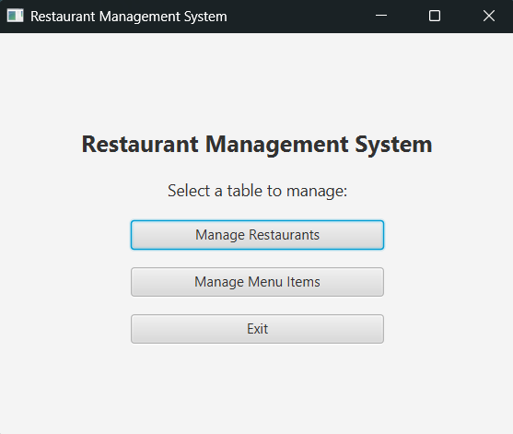

#Inserting
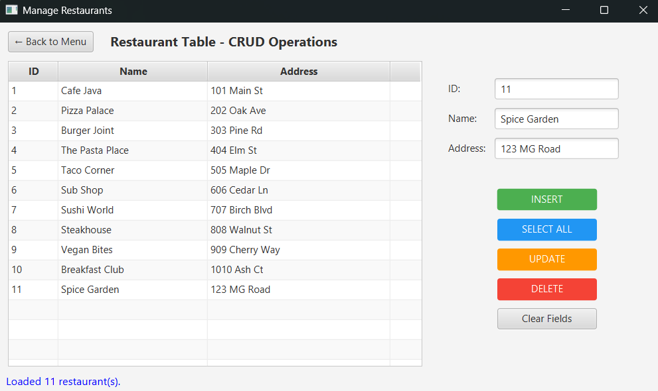
#Update

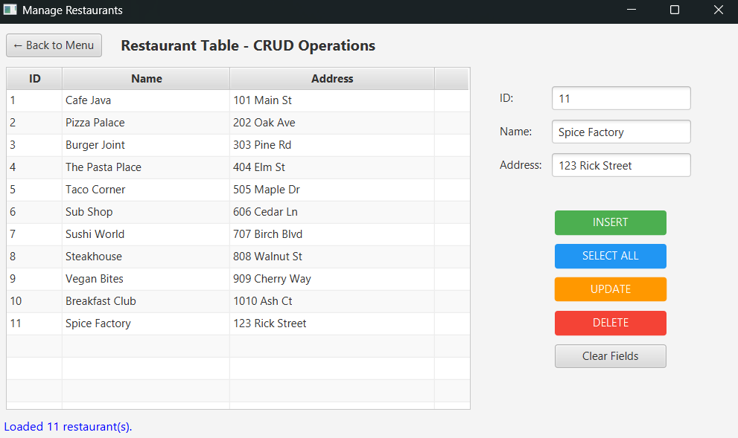

#Delete
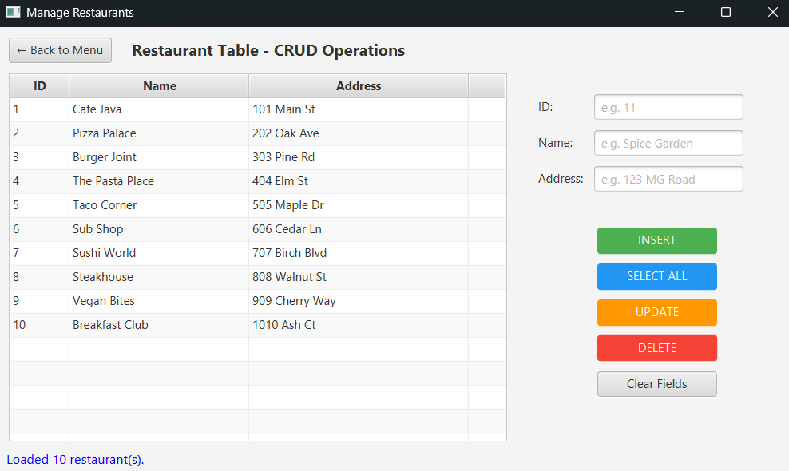

#Menu Table (Similarly Performing Records)

